American International University-Bangladesh · Department of Computer Science
CSC4161 · Advanced Programming in Web Technology
Project Report
ImpactID
A Verification-Based Volunteer Contribution Tracking and Impact Passport Platform
Group information
Group | 06 · Section E
Semester | Fall 2026–2027
Submitted to | Sultanul Arifeen Hamim, Lecturer, Department of Computer Science
Submission date | To be confirmed
Group members and contributions
SL | Student ID | Name | Section | Assigned modules | AI use
1 | 23-52918-2 | Umme Fahmida Sultana | E | Authentication, users and organizations | Pending
2 | 23-52867-2 | Emran Ahmed Tanzim | E | Impact Passport, skills, causes and public sharing | Pending
3 | 23-52849-2 | Shazzad Hossain Setu | E | Verification, fraud flags, audit logs and administration | Pending
4 | 23-52359-2 | Intisar Jaman Chowdhury | E | Opportunities, community requests, applications and participations | Pending
Setu used OpenAI Codex for backend implementation, tests and report drafting. Each member must confirm their final contribution and estimate AI usage across their own code, diagrams and report text.

1. Background study

1.1 Problem and objectives
A scholarship reviewer may receive an NGO certificate, a campus attendance sheet and a message from a neighbour for three activities claimed by one volunteer. Each record answers a different question. The reviewer still needs to establish who confirmed the work, how many hours they approved and whether that decision remains valid.
ImpactID links each decision to a recorded participation and its organizer or community requester. The project aims to prevent duplicate credit, keep organization and community confirmations distinguishable, record revocations and allow the volunteer to control what appears in a shared passport.

1.2 Existing approaches
Approach | What it captures | Verification gap
Attendance spreadsheet | An organizer can record many participants at one event. | A reviewer needs the original organization to confirm an entry or subsequent correction.
Paper or PDF certificate | An issuer identifies an activity and a recipient. | A static copy does not show whether the issuer later withdrew credit.
Self-written CV or profile | One volunteer can describe experience across organizations. | The claim alone contains no independent decision from the activity owner.

1.3 Technology choices
NestJS separates request validation, access guards and service logic. TypeORM carries a single database transaction through all four approval writes. PostgreSQL enforces foreign keys and uniqueness, and row locks serialize simultaneous decisions. Swagger exposes the HTTP interface. Jest checks error responses and persisted database state.

2. Requirement analysis

2.1 Functional requirements
ID | Requirement | Priority | Status
F1 | Register and authenticate a volunteer or organization using a bcrypt-protected password and a JWT. | High | Team integration
F2 | Create, list, read, update and archive core activity or catalog resources with pagination. | High | Team integration
F3 | Accept an application and record completion for the assigned volunteer. | High | Team integration
F4 | Allow the authorized owner to approve or reject a completed participation once. | High | Tested
F5 | Create one private impact record and append an audit entry when approval succeeds. | High | Tested
F6 | Allow an administrator to review organizations, change account status and review fraud flags. | High | Tested
F7 | Revoke verified credit atomically and retain the administrative reason. | High | Tested
F8 | Publish only shareable records and exclude revoked and self-reported hours from verified totals. | High | Team integration

2.2 Non-functional requirements
ID | Category | Measurable target | Check
N1 | Integrity | Two simultaneous approvals produce one decision and one impact record. | Race two requests in PostgreSQL.
N2 | Atomicity | Zero partial writes survive an audit insert failure. | Compare rows before and after the injected error.
N3 | Access | Missing or invalid token returns 401. An unauthorized role returns 403. | Signed-token HTTP tests.
N4 | Privacy | Every newly verified record starts PRIVATE. | Read the inserted impact record.
N5 | Usability | Lists default to 10 rows and reject limits over 100. | Validate the pagination DTO and response metadata.

3. Use cases and entity relationships

3.1 Actors and responsibilities
A volunteer may also act as a community requester. The API identifies the requester by ownership of a specific request. Organization accounts can verify work for approved organizations they own. An administrator can review evidence and withdraw a previous approval.
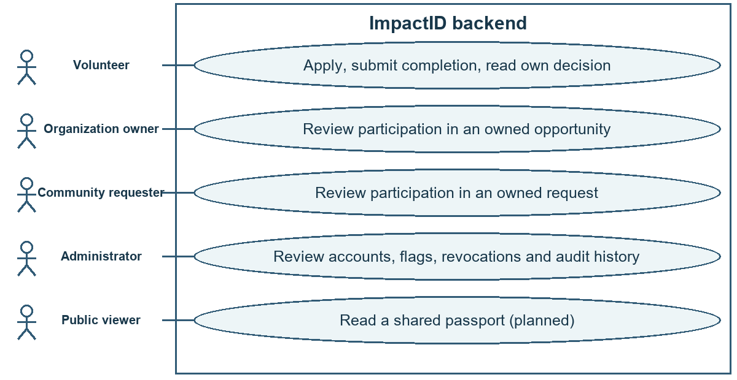
Figure 3.1. Actors and main use cases. Participation intake and passport sharing are team integration targets.

3.2 Main use cases
UC1 · Verify participation. An active owner selects a completed participation that is pending verification. The service checks the application, ownership and allowable hours. Approval returns 201 and creates private credit. Rejection requires a reason. A self-verification attempt yields 403 and a repeated decision yields 409.
UC2 · Revoke credit. An active administrator supplies the verification ID and a reason. The service checks for an approved verification, verified participation and active impact record. It changes all three statuses and appends an audit entry. Any failed write rolls back the transaction.

3.3 Entity relationship diagram
The migration creates 14 tables. The diagrams read left to right. Each label gives the permitted number of parent and child rows for that link. The primary key is id unless the diagram or accompanying text identifies another key.
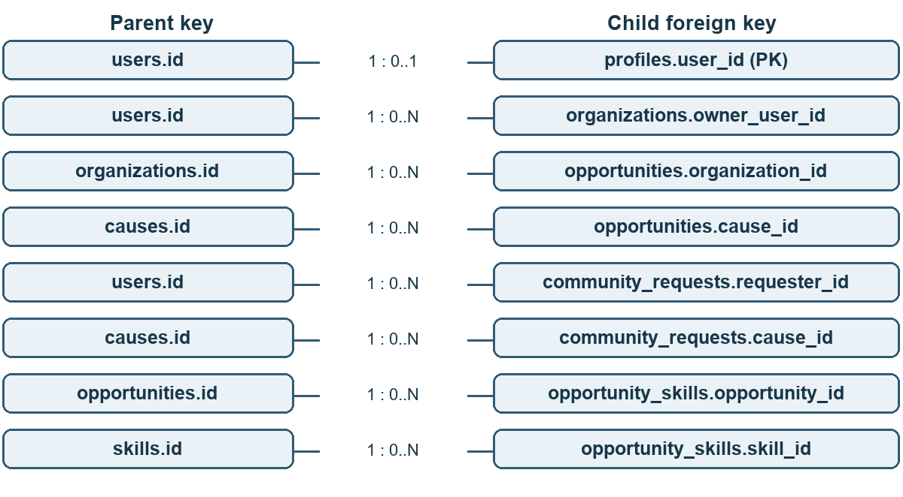
Figure 3.2a. Accounts, activities and skills. The two foreign keys in opportunity_skills form its composite primary key.
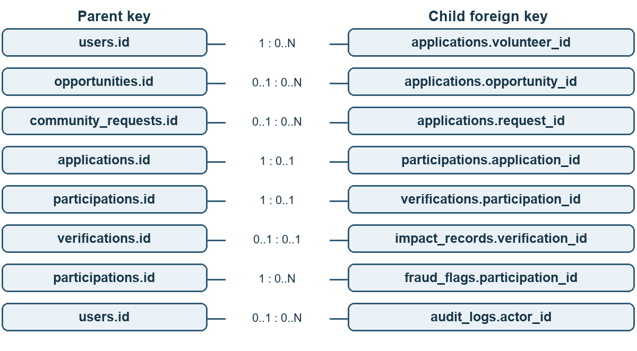
Figure 3.2b. Applications, completed work, verification evidence and audit history.

3.4 Relationship and constraint notes
Relationship | Cardinality | Meaning
Organization to opportunity | One to many | A single owner may manage several organizations. Each opportunity belongs to one organization.
Opportunity to skill | Many to many | The junction table prevents the same skill from being linked twice to one opportunity.
Application to activity | Exactly one target | A check constraint requires one opportunity or one community request. Separate unique rules prevent duplicate applications for the same volunteer and target.
Participation to decision | One to zero or one | A unique participation_id prevents competing verifications. A unique application_id also allows only one participation per accepted application.
Decision to impact record | Zero or one on each side | A verified impact record references one decision. A self-reported record has no verification. A rejected decision creates no impact record.
User to decision or record | One to many | verifications.verifier_id identifies the verifier. participations.volunteer_id and impact_records.volunteer_id identify the contributor.
Optional references | Zero or one parent per row | organizations.approved_by, fraud_flags.reviewed_by and audit_logs.actor_id reference users. impact_records.cause_id optionally references causes.
Audit target | Logical reference | target_type and target_id identify the affected resource. Together they describe several kinds of resource without a database foreign key.

4. Database normalization
Consider an illustrative worksheet for one opportunity with several required skills. A coordinator copies the organization name and volunteer email onto each participation row. The skills cell holds a list, and correcting one email may require edits to several rows.

4.1 Unnormalized form
Participation and application | Volunteer and opportunity | Repeated values
P1 · A1 | V1 · v1@example.test · O1 · River cleanup | G1 · Green Club · skills: sorting, first aid
P2 · A2 | V2 · v2@example.test · O1 · River cleanup | G1 · Green Club · skills: sorting, first aid

4.2 First normal form
Give each skill its own row. P1 now appears once for sorting (S1) and once for first aid (S2). P2 produces the same two skill rows. In this worksheet the composite key is (participation_id, skill_id). Each cell holds a single value.

4.3 Second normal form
skill_id determines the skill name alone. participation_id determines the application, volunteer and event details independently of skill_id. Split those attributes into Skill and ParticipationDetail. The remaining pairs express an event requirement. Since both volunteers inherit skills from O1, store (O1, S1) and (O1, S2) once in opportunity_skills.

4.4 Third normal form
In ParticipationDetail, application_id identifies the opportunity, opportunity_id identifies its organization, and organization_id determines the organization name. volunteer_id determines the email. Move these facts into applications, opportunities, organizations and users. Participations retains its unique application reference, contributor and completion facts. The service checks that the contributor matches the application.
The production schema also preserves history. An impact record stores the credited title and activity date when the owner approves the work. Revocation changes its status while preserving the original evidence.

5. Implemented APIs
The local service listens on port 5000. Swagger UI is available at /api/docs. The operations below are registered on feature/setu-verification. Each id or participationId is a UUID. Protected routes require a bearer token and an active account.

5.1 Verification
Method | Path | Purpose and input | Access
POST | /verifications/:participationId/approve | Approve completion. Optional confirmedHours overrides the submitted hours. | Activity owner
POST | /verifications/:participationId/reject | Reject completion with a nonblank reason. | Activity owner
GET | /verifications/:id | Read decision status, source and confirmed hours. | Participant, owner, admin

5.2 Administration
Method | Path | Purpose and input | Access
POST | /admin/verifications/:id/revoke | Withdraw verified credit. Requires reason. | Admin
PATCH | /admin/organizations/:id/approve | Approve a pending organization. Optional reason. | Admin
PATCH | /admin/organizations/:id/reject | Reject a pending organization. Optional reason. | Admin
PATCH | /admin/users/:id/status | Set status to ACTIVE or SUSPENDED. | Admin
GET | /admin/fraud-flags | List flags with pagination. | Admin
GET | /admin/fraud-flags/:id | Read the selected flag. | Admin
PATCH | /admin/fraud-flags/:id | Set an OPEN flag to CONFIRMED or DISMISSED. | Admin
GET | /admin/audit-logs | Read recorded changes with pagination. | Admin

5.3 Service checks
GET / returns a service identification string. GET /health returns status and a timestamp. Both are public. The team contract also defines identity, activity and passport operations for integration.

5.4 Request and response examples
The examples below show the JSON structure. IDs and timestamps in the examples are illustrative. The approval response excerpt shows selected fields.

Approval · POST /verifications/{participationId}/approve
Request body
{ "confirmedHours": 1.25 }
201 Created · response excerpt
{ "success": true, "data": { "id": "61abb612-7953-4067-a462-9bab23f64ea9", "type": "COMMUNITY", "status": "APPROVED", "confirmedHours": "1.25" } }

Fraud review · PATCH /admin/fraud-flags/{id}
Request body
{ "status": "DISMISSED" }
A successful review returns 200 with the flag, its updated status, reviewer ID and review time. Reviewing the same flag again returns 409.

Audit history · GET /admin/audit-logs?page=1&limit=10
200 OK · example on an empty database
{ "success": true, "data": [], "meta": { "page": 1, "limit": 10, "total": 0, "totalPages": 0 } }

Error responses
400 indicates an invalid body, UUID or pagination value. A missing or invalid token yields 401 when the JWT strategy is registered. Insufficient role or ownership yields 403. A missing resource yields 404. Duplicate decisions and invalid state transitions yield 409.
{ "success": false, "statusCode": 404, "message": "Verification not found", "path": "/verifications/61abb612-7953-4067-a462-9bab23f64ea9", "timestamp": "2026-11-09T00:00:00.000Z" }

6. Screenshots of functionality
Figure 6.1 shows the routes registered by the running backend. The integration suite uses signed test tokens. Screenshots of the complete signed-in workflow require the team login implementation and prepared demo accounts.
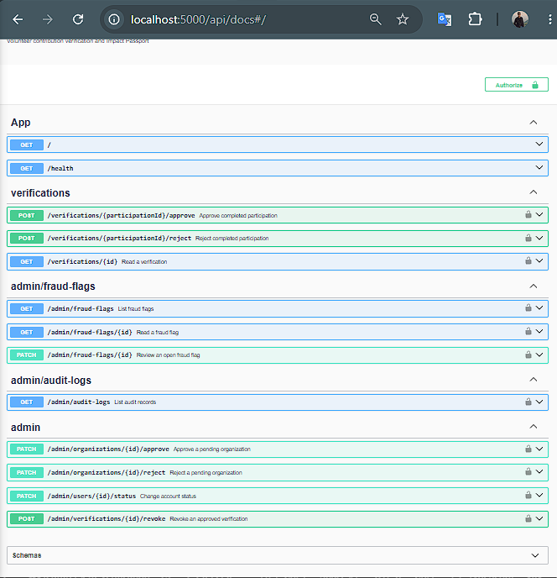
Figure 6.1. ImpactID API overview in Swagger UI.
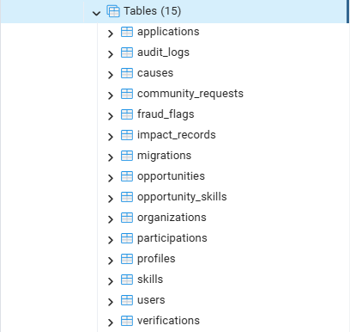
Figure 6.2. PostgreSQL tables in pgAdmin. The schema contains 14 application tables and the TypeORM migrations table.
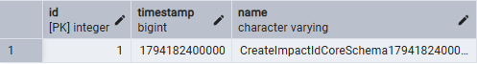
Figure 6.3. Entry 1 in the TypeORM migration history. The timestamp 1794182400000 matches the project migration CreateImpactIdCoreSchema1794182400000.
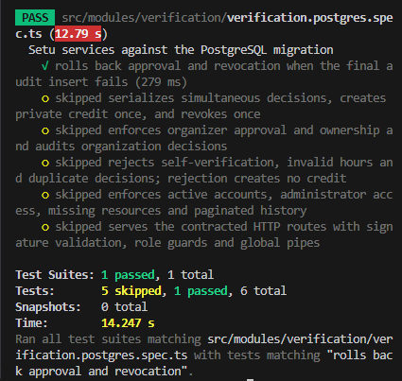
Figure 6.4. The PostgreSQL integration test passed for both approval and revocation rollback after a forced audit insert failure. This run selected one test and skipped the other five.

Evidence still to collect
Function | View to capture | Expected evidence
Identity and access | Register, login, missing-token and wrong-role requests | 201 on registration, a login response, 401 and 403. Conceal credentials and token values.
Core entity CRUD | Create, paginated list, detail, update and archive | Successful operations for at least four team core resources.
Decision and credit | Approve and reject distinct pending participations | 201, matching participation status, and one private impact record for the approval.
Bad input and conflict | Invalid hours, absent UUID resource and repeated approval | 400, 404 and 409 with request URL and response body.
Rollback | Deliberate audit failure in an isolated test schema | Before and after views of the same participation and counts of credit and decision rows.
Admin review | Organization and account status, fraud review, revocation and audit list | Actor, decision and status. Confirming a flag leaves the verification approved until a separate revocation.
Passport and sharing | Owner passport and public view after integration | A private or revoked record contributes no public verified credit.

7. Implementation highlights

7.1 Authorized ownership and hours
The service loads the authenticated account and follows the participation to its application. For an opportunity it checks the organization owner and approval status. For a community request it checks the original requester. The participant cannot verify their own work. A reviewer may confirm at most the overlap between the scheduled activity and the interval from acceptance to completion. A non-time-based activity earns no hours.

7.2 Atomic approval and revocation
Approval begins a TypeORM transaction and locks the participation for writing. After validating its current state, the service inserts a verification, updates the participation, creates the private impact record and appends an audit entry using the same manager. A concurrent approval waits for the lock, then encounters the changed state and returns 409.
Revocation locks the verification. It requires one verified participation and one active impact record. If either update affects the wrong number of rows, the transaction fails. The audit entry records the administrator and reason. Rejecting an initial submission ends the participation without producing credit.

7.3 Verification results
Test group | Observed result | Boundary
Foundation and input | 6 foundation and 14 validation tests passed. | Covers module wiring, metadata, configuration and selected validation rules.
PostgreSQL integration | 6 tests passed against the initial migration in isolated schemas. | Covers concurrent decisions, ownership, rollback, administrative review and pagination.
HTTP and Swagger | The integration suite registered 11 protected operations and exercised 400, 401, 403, 404 and 409. | Used a signed token and a test-only Passport strategy.
Build and tooling | Nest build, TypeScript check and scoped lint passed on Node 24.16.0. | The project targets Node 22. An integrated Node 22 run remains to be confirmed.

8. Conclusion and references
ImpactID can record who confirmed a volunteer contribution and withdraw that credit while retaining the evidence. PostgreSQL tests showed that two concurrent approvals produced one private impact record and that an audit failure rolled back the other writes. Fraud review and revocation are separate decisions with separate audit entries.
The remaining demonstration connects production login, application acceptance, participation completion and passport rendering with these verification endpoints. The team must also document four complete CRUD resources, record its final AI usage estimates and add captioned evidence from the integrated application.

References
CSC4161 Project Proposal Guide and Sample Project Report, Part A, sections 4, 8 and 10. October 2026.
ImpactID project proposal. Group 06, Section E. 18 October 2026.
ImpactID Volunteer Platform repository. docs/API_CONTRACT.md, docs/DATABASE_CONTRACT.md and the initial TypeORM migration. https://github.com/Noobie33/impactid-volunteer-platform
Setu verification implementation and test evidence. docs/SETU_IMPLEMENTATION_REPORT.md and src/modules/verification/verification.postgres.spec.ts.

